***Hybrid Link https://uconn-cmr.webex.com/meet/brg20004*****

- Call to Order: Alaa Selim (VP)

- Recognition of Senators
- Curam was established.
- Attendance marked.

- Approval of consent agenda:
  - GSS Executive Committee Minutes – 2/15/24, 3/19/24 and 4/9/24 meetings
  - GSS Senate Meeting Minutes - 3/20/2024 meeting
- The last meeting minutes approved: Motion 2nd by Elive and Sandip.
- No abstains.
- No declines

Issues Forum:
- Recreational center issue, students +1 situation needs to be figured out.
- Bryan: we will try to work on that and will let you know the update.

- Executive Board Reports:
  - President –Bryan Greene (Incoming AY 2024-25)

- 445 pages on the report, based on the notes, a lot of stuff needs to be done starting from the Orientation of new senators.

  - Vice President – Alaa Selim (Incoming AY 2024-25)
- Bookings for rooms: All the rooms should be in the same building room for meetings.
- Issue Martina : The student union requires food catered from the SU.
- Gupta: we can request to bring outside food
- Sandy: motion first meeting in SU and then decide what to do. Martina and Sandip 2nd the motion No abstains. No declines, motion passed.

Procedure for motion discussions.

  - Treasurer- Gopi Yalavarthi/Emma Dashnaw (Incoming AY 2024-25)
- 146, 431 $ budget, needs to decide on 2-3 tier 2 organizations then the budget will be finalized
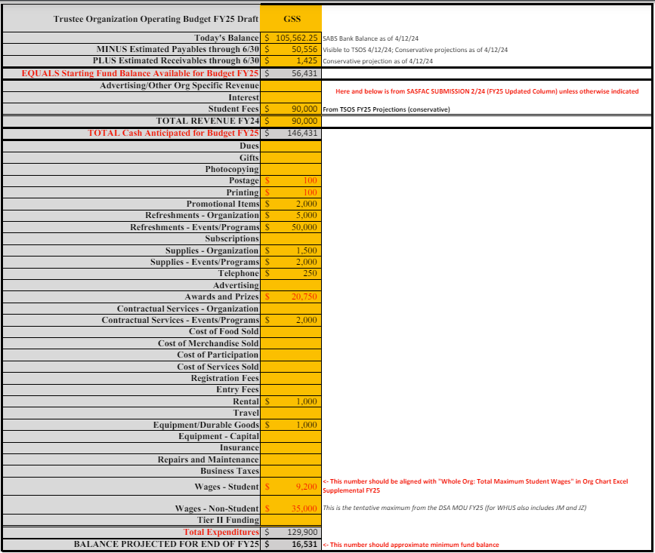

- Martina and aliev 2nd the motion by Gopi
- Hanna and Gabriel abstain Sandip oppose.
- Motion is passed

  - Communications Director – Maham Liaqat/Gaurav Gupta (Incoming AY 2024-25))
- Need volunteers for committees need to revive the old committees, next e-board can decide on the division.
  - Activities Director-Essam Boraey/Vacant (Incoming AY 2024-25)

- GSS got frozen so all the events got cancelled.

  - Parliamentarian – Bryan Greene (acting)/Noah Kravette (Incoming AY 2024-25)

- Old Business-Election of GSS Activities Director, Motions on E-Board Compensation
Defined the Established the role and duties of the activity’s director. No nominations yet.

- New Business-Approval of GSS FY 2025 Budget, On-Boarding/Orientation Process, OCS Investigation
Motion to Pay Current and Past E-Board Members the following compensation:

- Former GSS President Roy: $2500 for Fall Semester 2023 (payable immediately), GSS President Greene $2500 (payable after April 24, 2024)
  - Aye: 10
  - Nay: 1
  - Abstain: 4

- Former Parliamentarian Djebbari: Amount of outstanding stipend up until February 21, 2024, $375

- GSS Communications Director Liaqat-Amount of Stipend from February 21, 2024 to end of Academic Year, $750

- GSS Vice President Selim-Amount of Stipend from February 21, 2024 to end of Academic Year, $375

- GSS Activities Director Boraey-Outstanding Amount of Academic Year Stipend, $1500 (payable after April 24, 2024)

- GSS Treasurer -Outstanding Amount of Academic Year Stipend, $2500 (payable after April 24, 2024)

- **All payments are paid as fellowship payments for tax and visa purposes**
For all payments for everyone above. Motion Passes for payment as above.
  - Aye: 13
  - Nay: 1
  - Abstain: 4
- Motion is passed.

Motion to provide compensation for the following GSS Officers under the following parameters:

GSS President-Monthly payments for the total stipend ($5000) effective after May 1, 2024

GSS Treasurer-Monthly payments for the total stipend ($5000) effective May 1, 2024

**All payments are paid as fellowship payments for tax and visa purposes**
- Sandip and Krista 2ND the motion.
- 1 abstain.
- No oppose.
- Motion passed.

Motion 3-On Boarding/Orientation Amendment
to the Bylaws

At the beginning of every school year, all new and returning GSS Members (including E-Board
Members) must attend a mandatory Onboarding/Orientation meeting before the first official GSS
Meeting where official votes and business will be taken

The meeting will establish a voting and meeting agenda system in compliance with Robert’s Rules of
Order

The meeting will focus on the responsibilities/structure of Tier III Organizations, Membership
expectations and responsibilities along with Diversity, Equity, and Inclusion training.
- Motion 2nd by Sandip and sandy
- 18 ay
- No abstain no opposing

Motion 4-Adoption of OCS Investigation
Recommendations

Once a final report has been submitted to the Graduate Student Senate (or its designee) at the conclusion of the investigatory process, the Graduate Student Senate agrees to implement all recommendations set forth by the Office of Community Standards unless a compelling or extenuating circumstance prevents GSS from compliance.

Any non-compliance with the recommendations set forth by the OCS must be communicated in
writing to the GSS and broader graduate student community, with a detailed explanation as to why
GSS cannot/will not be compliant with one or more recommendations.
Sandip and Elive 2nd the motion
- 15 in favour
- 1 abstain, no opposing.
Motion Passed

- Good News

- Adjournment

Meeting adjourned at 8:01 pm.

